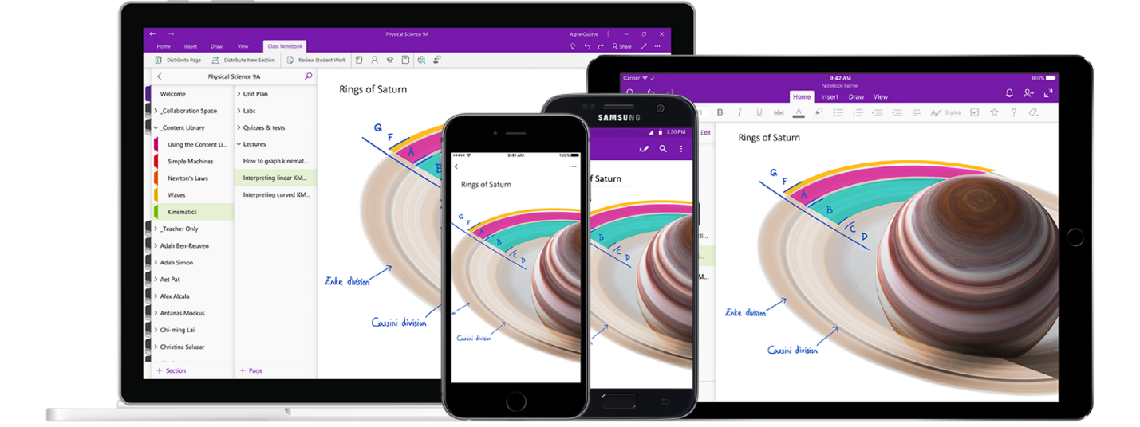

Figure 1 cited from [Microsoft OneNote’s Official Website](https://www.microsoft.com/zh-cn/microsoft-365/onenote/digital-note-taking-app?ms.url=onenotecom&rtc=1)

Analyzing the Design of Microsoft OneNote - version 16.0.13530.20440 or later

Software Analysis and Design Report | Jan 30th 2021 | Hairong Wu (Jason) | 1683 words

# About the Product

Microsoft OneNote is one of the bundled software in Microsoft 365 series. It focuses on providing both students and workers in various fields with simple and powerful features to take notes. One can simply click on the small icon within the task bar and start recording their contents. Users can also create different notebooks for various purpose, by naming a notebook can they recognize what this notebook is used for. In addition, within a notebook, tabs can be created to filter huge sections of users’ projects or lectures. They can also add pages for detailed contents, pictures and drawing.

I choose to make a research on Microsoft OneNote is because I’m always one of the stakeholders of it and, with no doubt, this software would keep influencing its stakeholders by providing new features which might have advantages or drawbacks. It is indeed that the latest version of OneNote (I believe starting at the version of 16.0.13530.20440 or later) has great updates on both its features and software layouts, which has costed effects not only on me but on other stakeholders and even several potential future users; for instance, users who prefers to create plenty of tabs would find it hard to switch between their tabs because all the tabs will be automatically combined.

Therefore, in this research paper, I will discuss on the current direct stakeholders, indirect stakeholders, design critiques and a redesign proposal for a possible prototype

# Stakeholder Research

## Direct Stakeholders

Recall that direct stakeholders are those who directly use the device/system. **Spend some time researching their primary motivations**, goals, and values in the context of this design. Why are they unhappy with the design and in general, and how does it fall short?

Answer the following questions:

* Why do you think these people are a direct/indirect stakeholder group for this design?
* List specific research methods you used (interviews, observations, surveys, review of online discussions, user testing etc.). Do not forget to put your interview transcript research notes, survey results in an appendix at the end.
* What research method did you select? Why did you select this research method? How did you research this group?
* What did your research reveal about their primary motivations, goals, and values?
* In general, how is the current design not satisfying their primary motivations, goals, or values?

## Indirect Stakeholders

Indirect stakeholders are those who don't directly use it, but are nevertheless affected by its use. Identifying relevant indirect stakeholders can sometimes be tricky, so think broadly and feel free to ask your TA for guidance if you are unsure.

Answer the following questions:

* Why do you think these people are an indirect stakeholder group for this design?
* In general, how would you *assume* the current design is not satisfying their motivations, goals, or values?

# Design Critique (do not forget to check out our design critique resources)

The next step is to dive into the details of the design to determine exactly why it is not satisfying your stakeholder groups. Analyze the overall user experience as well as the detailed interaction design. If a software user interface is involved, analyze it according to the principles you read about and discussed in class. Consider how accessible the design is for people with varying levels of ability. If relevant, also consider whether the security of the system adequately addresses your stakeholders' goals and values.

Add a section to your paper in which you discuss the various problems you discovered. Include **at least 2 significant problems**, and for each, explain in detail why you think it is a problem. If it's an interaction design problem, be sure to use the interaction design vocabulary to explain what's wrong. If it's a UI problem, reference the relevant UI design principles. Include pictures or screenshots that illustrate the problem.

## Problem 1 Label

**Make sure to tie this back into your stakeholders!**

Lorem ipsum dolor sit amet, consectetur adipiscing elit. Vestibulum quis tellus aliquam ligula congue dapibus et eget erat. Maecenas iaculis est non laoreet pellentesque. Sed ut diam sagittis, tincidunt leo vitae, ornare lectus. Nulla tempor sapien quam, eu convallis odio ultrices et. Nunc bibendum, enim sed faucibus cursus, nibh nisi dapibus enim, ut condimentum diam tortor ut mauris. Proin et tempus dolor, ut aliquet enim. Nulla et elementum tortor. Morbi nunc enim, finibus eu sagittis nec, ornare vel tellus. Interdum et malesuada fames ac ante ipsum primis in faucibus. Vestibulum ac tellus nisi. Quisque eget feugiat ex. Lorem ipsum dolor sit amet, consectetur adipiscing elit. Aenean bibendum, nulla ac euismod vestibulum, urna est fermentum massa, ut posuere erat augue pretium tellus.

Etiam imperdiet mollis ultricies. Sed ac tortor vestibulum orci laoreet consequat. Morbi eu enim molestie, hendrerit felis ut, iaculis nisi. Class aptent taciti sociosqu ad litora torquent per conubia nostra, per inceptos himenaeos.

*Do not forget to include an annotated screenshot or picture of the problems in the product you are critiquing. Below is an example of how you can annotate the problems in the UI of a software or app.*  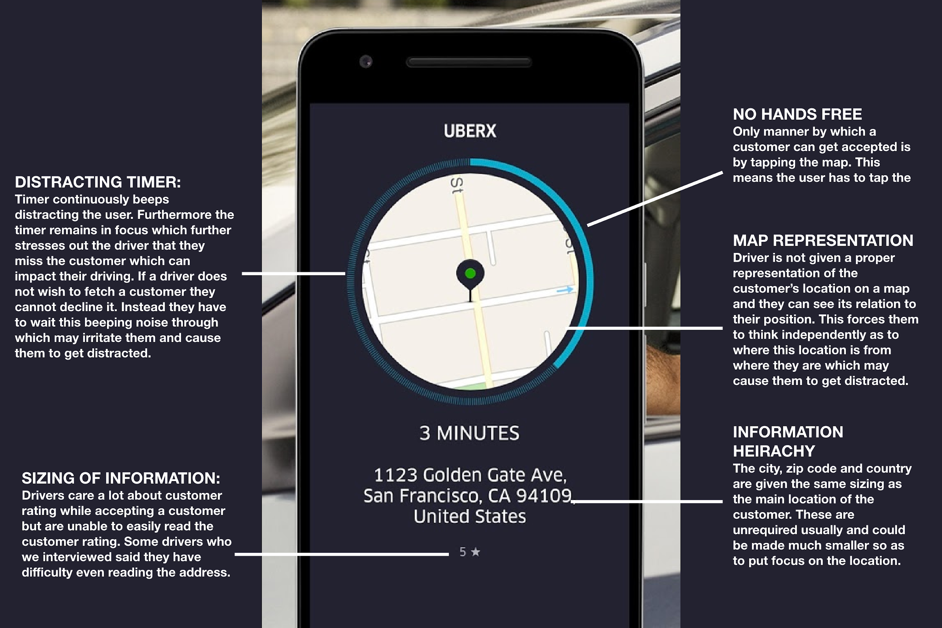

## Problem 2 Label

*Do not forget to include an annotated screenshot or picture of the problems in the product you are critiquing. Below is an example of how you can annotate the problems in the UI of a software or app.*

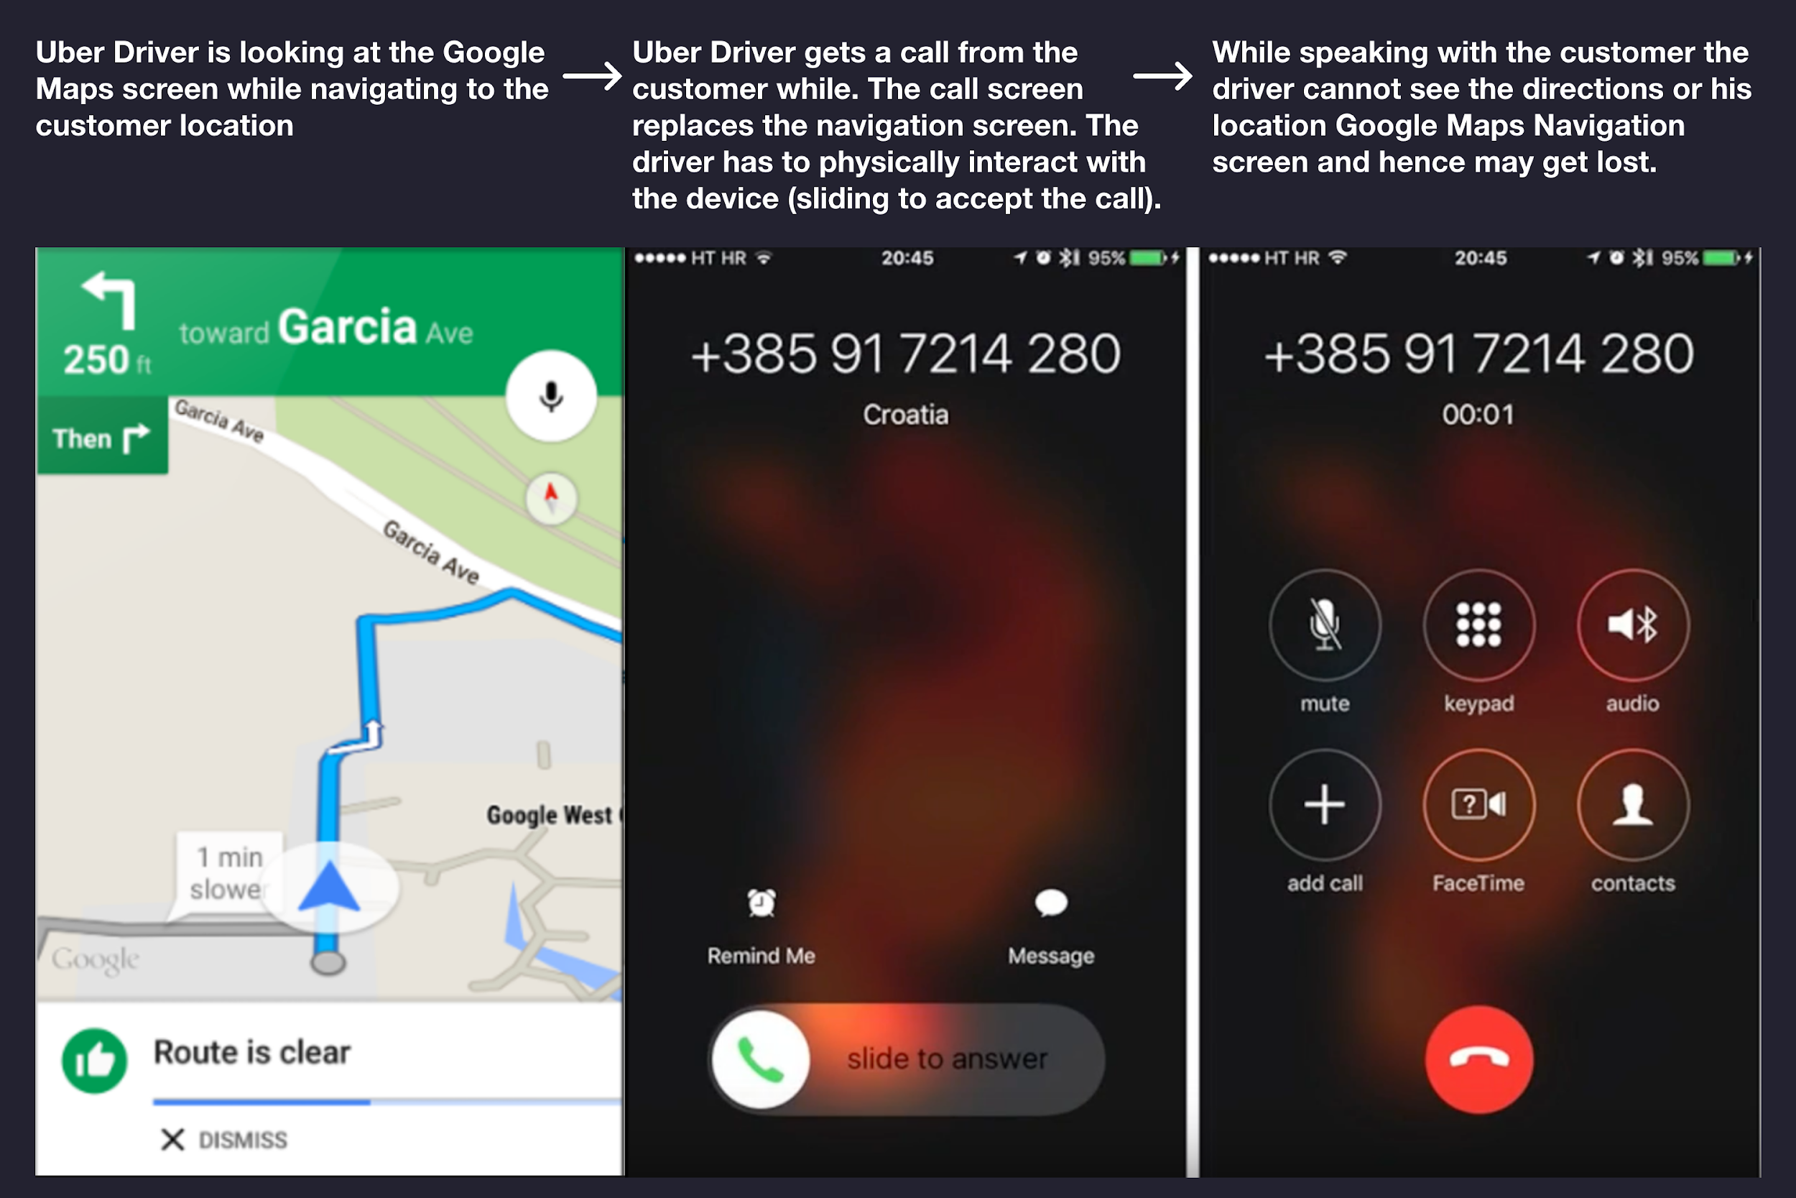

**Make sure to tie this back into your stakeholders!**

Lorem ipsum dolor sit amet, consectetur adipiscing elit. Vestibulum quis tellus aliquam ligula congue dapibus et eget erat. Maecenas iaculis est non laoreet pellentesque. Sed ut diam sagittis, tincidunt leo vitae, ornare lectus. Nulla tempor sapien quam, eu convallis odio ultrices et. Nunc bibendum, enim sed faucibus cursus, nibh nisi dapibus enim, ut condimentum diam tortor ut mauris. Proin et tempus dolor, ut aliquet enim. Nulla et elementum tortor. Morbi nunc enim, finibus eu sagittis nec, ornare vel tellus. Interdum et malesuada fames ac ante ipsum primis in faucibus. Vestibulum ac tellus nisi. Quisque eget feugiat ex. Lorem ipsum dolor sit amet, consectetur adipiscing elit. Aenean bibendum, nulla ac euismod vestibulum, urna est fermentum massa, ut posuere erat augue pretium tellus.

Etiam imperdiet mollis ultricies. Sed ac tortor vestibulum orci laoreet consequat. Morbi eu enim molestie, hendrerit felis ut, iaculis nisi. Class aptent taciti sociosqu ad litora torquent per conubia nostra, per inceptos himenaeos. Nunc sed sem urna. In ut accumsan dui. Quisque ultrices, est quis euismod ultricies, velit ante consequat enim, at dignissim mauris lacus eget urna. Aliquam egestas odio vitae leo rhoncus bibendum.

## Design Critique Tips and Resources

When critiquing a design do not forget to make use of the appropriate design key terms and make reference to good design principles not followed. If you refer to an article do not forget to cite it.

*We recommend that you read the following articles on the principles of interaction design, affordances and signifiers:*

* <https://medium.com/@sachinrekhi/don-normans-principles-of-interaction-design-51025a2c0f33>
* <https://medium.com/@Ben.Olson/affordances-and-signifiers-in-mobile-interface-design-cf584696cda8>
* <https://www.uxbooth.com/articles/complete-beginners-guide-to-information-architecture/>
* <https://uxdesign.cc/psychology-design-4-gestalt-principles-to-use-as-your-next-design-solution-fcdec423a6bf>
* <https://lawsofux.com/>
* <https://goodui.org/>

Below are some important key terms and their definitions:

**Affordances:**

An affordance is what an object can do based on user interaction.

**Example:**

A chair reveals its affordance by design, its shape mirrors the body and communicates its intent: to be sat on.

However, a chair has an additional affordance not communicated by its design. A chair can be used to change a light bulb or reach a book, a hidden affordance.

**Signifiers:**

A signifier clarifies an affordance, it illustrates or describes what an object can do. A signifier can be blatantly obvious or very subtle.

**Example:**

A door may have a slot. The slot is an affordance — objects may be placed through the hole. However, the slot may be accompanied by the text “Mail” which is a signifier that indicates the purpose of the affordance by offering instructions on what objects should be placed through the hole.

**Mapping**

Mapping is about having a clear relationship between controls and the effect they have on the world.

**Visibility**

Visibility is the basic principle that the more visible an element is, the more likely users will know about them and how to use them.

**Feedback**

Feedback is the principle of making it clear to the user what action has been taken and what has been accomplished.

# Redesign Proposal

Lastly, add a section to your paper in which you propose changes to the design thatfix **one of the problems you identified**, for the stakeholders you identified. This problem should be fundamental to the use of the product. If possible, include drawings or mock-ups of your proposed changes.

For example, if you found problems with the UI design, include sketches of a better UI and describe how your new UI better adheres to the UI design principles. If you found problems with the interaction design, include sketches of a better design that address those problems, and use the interaction vocabulary to explain why it's better. **Include these sketches in your paper** so that we can better understand your redesign.

*When proposing your design ideas do not forget to mention the assumptions you made, the limitations and alternate designs which you could consider.* ***Show two design variations of your idea****, or mention other possible variations on each redesign.*

*If you iterated through various ideas, show that through a picture of all your ideas together. We like to see your design thinking process.*

## Idea 1 - Redesign of Issue

Vestibulum ac tellus nisi. Quisque eget feugiat ex. Lorem ipsum dolor sit amet, consectetur adipiscing elit. Aenean bibendum, nulla ac euismod vestibulum, urna est fermentum massa, ut posuere erat augue pretium tellus.Vestibulum ac tellus nisi. Quisque eget feugiat ex. Lorem ipsum dolor sit amet, consectetur adipiscing elit. Aenean bibendum, nulla ac euismod vestibulum, urna est fermentum massa, ut posuere erat augue pretium tellus.

Vestibulum ac tellus nisi. Quisque eget feugiat ex. Lorem ipsum dolor sit amet, consectetur adipiscing elit. Aenean bibendum, nulla ac euismod vestibulum, urna est fermentum massa, ut posuere erat augue pretium tellus. Vestibulum ac tellus nisi. Quisque eget feugiat ex. Lorem ipsum dolor sit amet, consectetur adipiscing elit. Aenean bibendum, nulla ac euismod vestibulum, urna est fermentum massa, ut posuere erat augue pretium tellus.

*Do not forget to include a high-quality annotated screenshot or picture of the redesign you made. It can be a simple low fidelity sketch or a high-fidelity wireframe.*

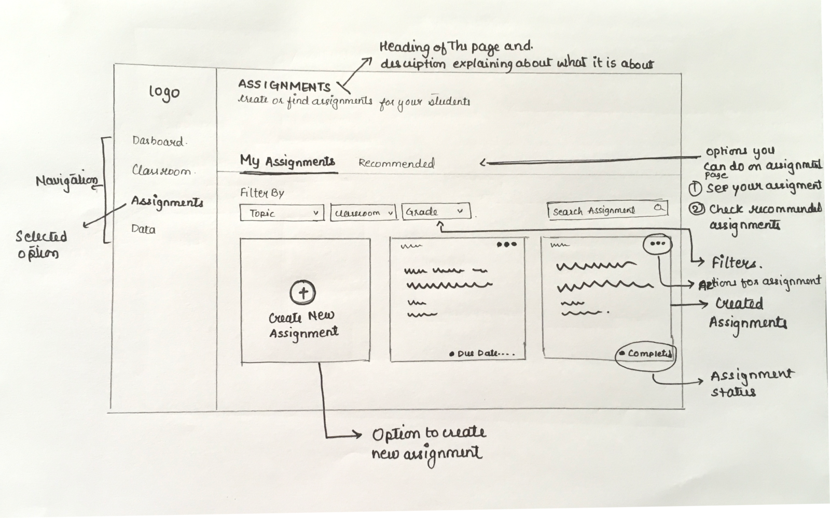

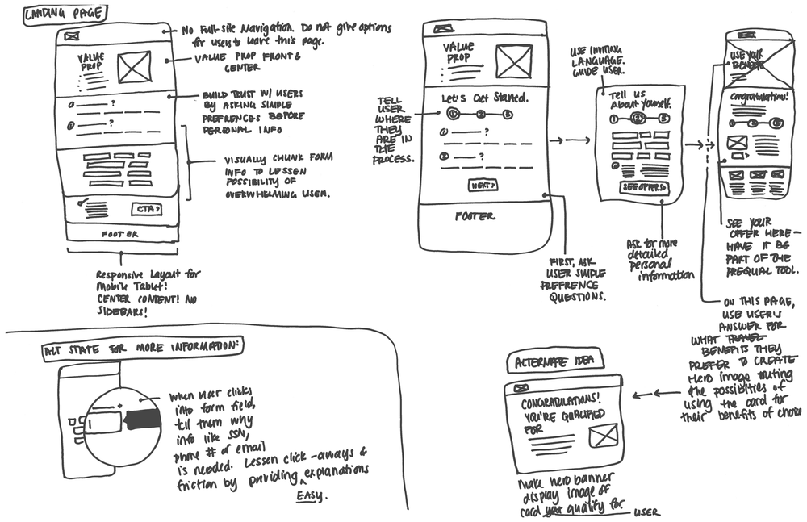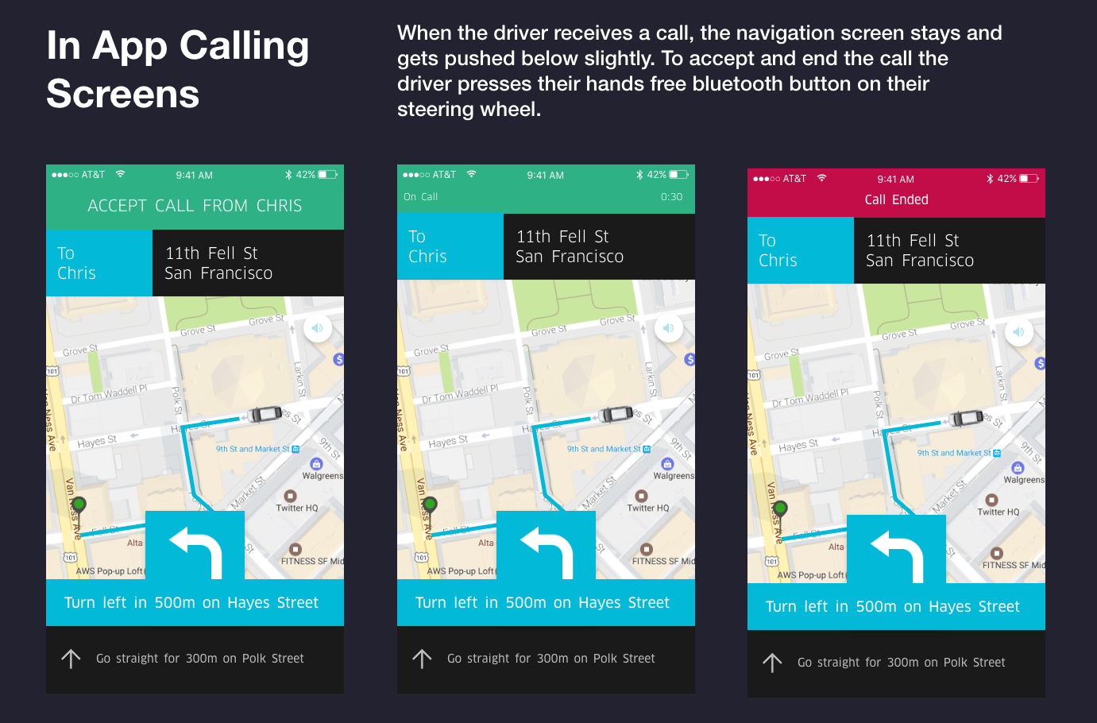

## 

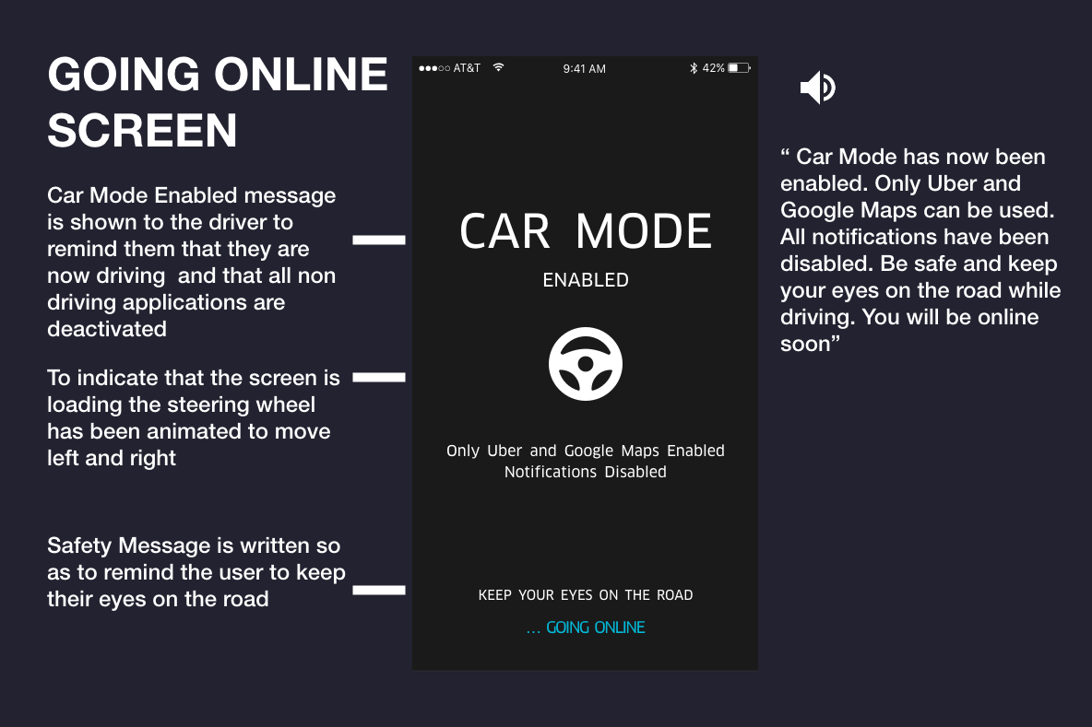

# References

Use APA. Do not forget to cite the websites and articles you refer to.

# Appendix

* Interview Transcripts
* Survey Results
* Additional screenshots
* More design ideas and wireframes
* More information about the product

There is no minimum length for the paper, just be sure you addressed all the questions. Max length is ~1750 words **excluding references and the appendix**. If you reference external sources, be sure to cite those sources properly. You may want to re-read the plagiarism section of the course syllabus page.